Team Green Backlog

US06 Display picture feed

Story: As a signed-in user, I want to see a list of pictures other users have added which might be of interest to me so that I can get new ideas or see new things.

Scenario & Storyboard:
- (Assume) User has signed-in.
- (1) From any page, click Home in navbar.
- (2) User sees feed.

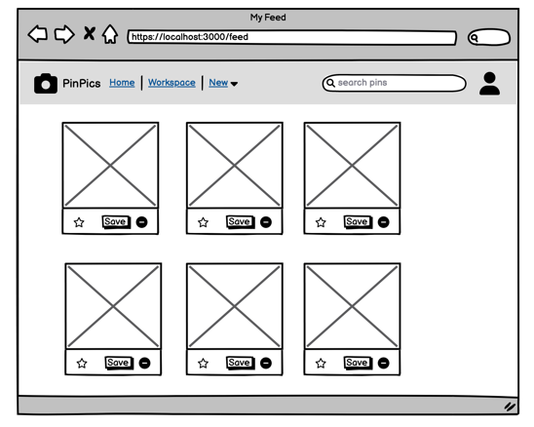
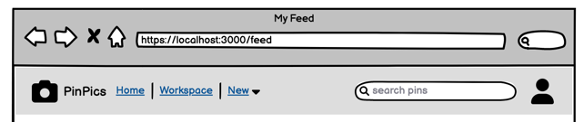
(1) Click Home

(2) Feed

Milestone M1 Task:
- Plan:
  - Assigned to: Homer Simpson
  - Planned Code Changes:
    - Add home button to Navbar (1).
    - Create Feed page with Pin display (2).
    - Create Pin model and seeds (if not already).
- Outcome:
  - Status: Complete
  - Pull Request: https//github.com/green/pin-pics/1

US25 Save pin

Story: As a signed-in user, I want to save other users pictures to my personal workspace so that I can keep track of the ones I really like.

Scenario & Storyboard:
- (Assume) User has signed-in and is viewing the feed (US06).
- (1) Click "Save" button on pin.
- (2) Button text changes to "Saved".
- (3) Saved pin appears in personal workspace (US14).

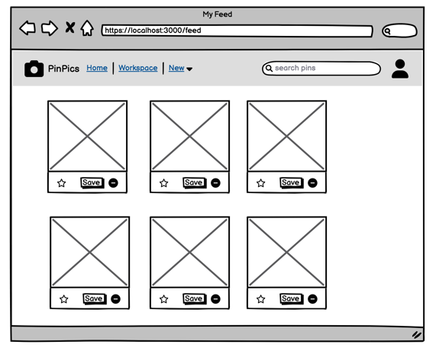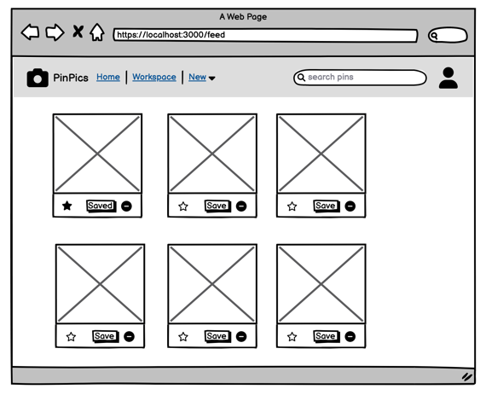
(2) Button text changes to “Saved”
(1) Click Save on pin

Milestone M1 Task:
- Plan:
    - Assigned to: Bart Simpson
    - Planned Code Changes:
    - Create Feed page with Pin display (if not already).
    - Create Pin model + seeds (if not already).
    - Create SavedPin model + associations to User/Pin.
    - Add Save Button with create SavedPin controller action (1).
    - Add logic to change Saved button to Saved if SavedPin exists for current user (2).
- Outcome:
  - Status: Complete
  - Pull Request: https//github.com/green/pin-pics/2

US14 Display saved pins

Story: As a signed-in user, I want to see a list of saved pins in my personal workspace so that I organize some of them into boards.

Scenario & Storyboard:
- (Assume) User has signed in.
- (1) From any page, click Workspace in navbar.
- (2) User sees personal workspace.
  - (2a) If user has saved pins.
  - (2b) If user has no saved pins.

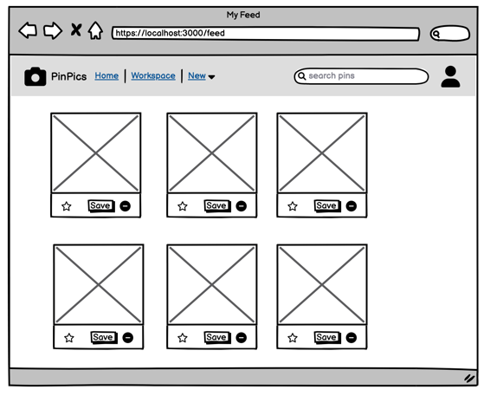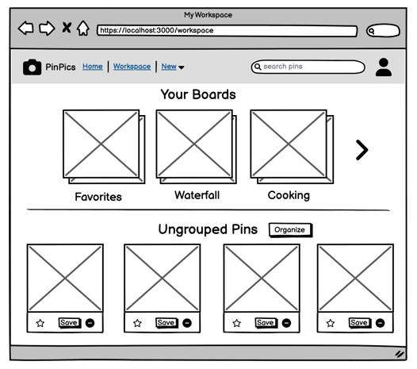
(2a) Personal Workspace with saved pins
(1) Click Workspace

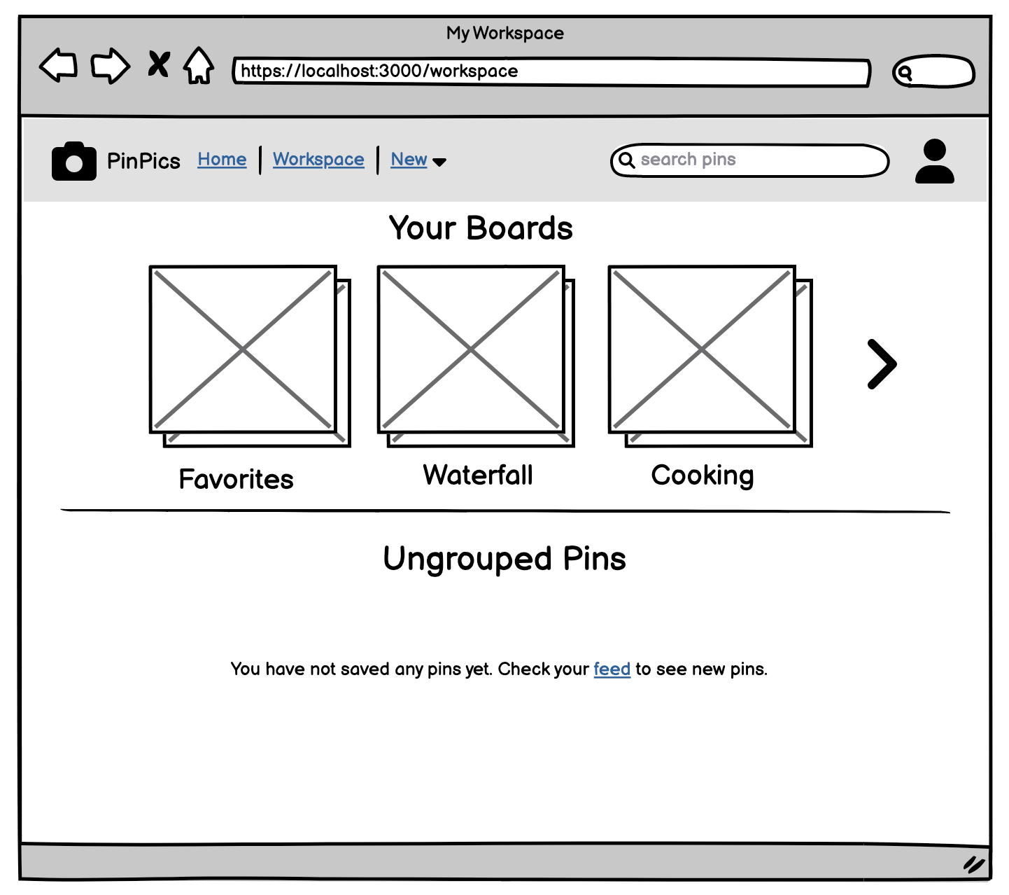
(2b) Personal Workspace with no saved pins

Milestone M1 Task:
- Plan:
  - Assigned to: Lisa Simpson
  - Planned Code Changes:
    - Add Workspace button to navbar (1)
    - Create Workspace page
    - Depends on US25 for SavedPin association
    - Add Saved Pin display if current user has SavedPins (2a)
    - Add logic for no ungrouped pins display with message + link to feed (2b)
- Outcome:
  - Status: Partially complete; everything complete except message when no saved pins
  - Pull Requests:
    - https//github.com/green/pin-pics/2 (SavedPin association)
    - https//github.com/green/pin-pics/3 (Workspace page, display SavedPins)

Milestone M2 Task:
- Plan:
  - Assigned to: Lisa Simpson
- Outcome:
  - Status: Complete
  - Pull Request: https//github.com/green/pin-pics/4 (Display message when no SavedPins)

